BA PART1
MICRO ECONOMICS
THEORY OF ELASTICITY OF SUPPLY
PAPER 1
LECTURE1
TOPIC :- THEORY OF SUPPLY

THEORY OF ELASTICITY OF SUPPLY

Following are different types of elasticity of supply:-

Perfectly Elastic Supply:- Refers to a situation when the quantity supplied completely increases or decreases with respect to proportionate change in the price of a product. In such a case, the numerical value of elasticity of supply ranges from zero to infinity (e_{S} = 00).This situation is imaginary as there is no as such product whose supply is perfectly elastic.
Therefore the situation does not have any practical implication. In such a case, the price remains constant as the price of a product does not affect the quantity supplied. Let us understand the concept of perfectly elastic demand with the help of an example.

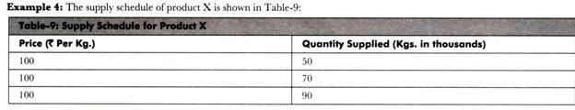
Prepare a supply curve for the supply schedule of product X and determine the type of elasticity of supply demonstrated by the supply curve.

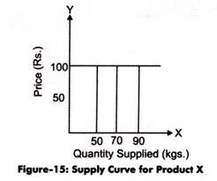

Figure-15 shows that the price of product X remains constant at Rs. 100 per kg. However, the quantity supplied changes from 50,000 Kgs to 90,000 Kgs at the same price rate. Therefore, the supply of product X is perfectly elastic (e_{S} = 00).

Relatively Elastic Supply:-Refers to a condition when the proportionate change in the quantity supplied is more than proportionate change in the price of a product. In such a case, the numerical value of elasticity of supply is greater than one (e_{S}>1) For example, if the quantity supplied increases by 30% with respect to 10% change in the price of a product, it is called relatively elastic supply. The concept of relatively elastic supply is explained with the help of an example.

Example 5:
The quantity supplied and the price of product P is shown in Table-10:
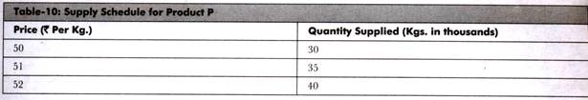
Prepare a supply curve for the supply schedule of product P and determine the type of elasticity of supply demonstrated by the supply curve.
Solution:
The supply curve for product P is shown in Figure-16:
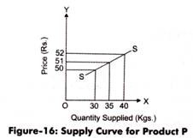

In Figure-16, when the price of product P is Rs. 50, the quantity supplied is 30,000 Kgs. However, when the price increases to Rs. 51, supply reaches to 35,000. Similarly, when the price further increases to Rs. 52, the supply reduces to 40,000 Kgs.
This shows that the change in price is only one rupee while the change in supply is 5,000. In other words, the proportionate change in quantity supplied is more than the proportionate change in the price of product P. Therefore, the supply of product P is highly elastic (e_{S}>1).

Relatively Inelastic Supply:-Refers to a condition when the proportionate change in the quantity supplied is less than proportionate change in the price of a product. In such a case, the numerical value of elasticity of supply is less than one (e_{S}<1). For instance, the elasticity of supply would be less than unit, if the quantity supplied increases by 20% with respect to 30% change in the price of a product.

Example-6:
The quantity supplied and the price of product Z is shown in Table-11:
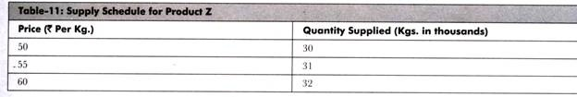
Prepare a supply curve for the supply schedule of product Z and determine the type of elasticity of supply demonstrated by the supply curve.
Solution:
The supply curve for product Z is shown in Figure-17:
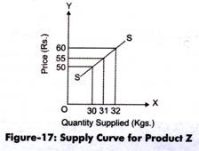
In Figure-17, when the price of product Z is Rs. 50, the quantity supplied is 30,000 Kgs. When price increases to Rs. 55, supply reaches to 31, 000. Similarly, when the price of product Z increases to Rs. 60, the supply increases to 32,000 Kgs. This shows that S change in price is five rupees while the change in supply is 1,000. In other words, the proportionate change in quantity supplied is less than the change in the price of product Z. Therefore, the supply of product Z is relatively inelastic (e_{S}<1).

Unit Elastic Supply:Refers to a situation when the proportionate change in the quantity supplied is equal to the Proportionate change in the price of a product. The numerical value of unit elastic supply is equal to one (e_{S}=1).

Example 7: The quantity supplied and the price of product Y is shown in Table-12:
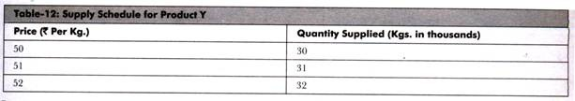
Prepare a supply curve for the supply schedule of product Y and determine the type of elasticity of supply demonstrated by the supply curve.
Solution:
The supply curve for product Y is shown in Figure-18:
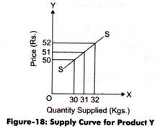
In Figure-18, when the price of product Y is Rs. 50, the quantity supplied is 30,000 Kgs. When price increases to Rs. 51, supply reaches to 31,000. Similarly, when the price increases to Rs. 52, the supply increases to 32,000 Kgs. This shows that the proportionate change in quantity supplied is equal to the change in the price of product Y. Therefore, the supply of product Y is unit elastic (e_{S}=1).

Perfectly Inelastic Supply:-Refers to a situation when the quantity supplied does not change with respect to proportionate change in price of a product. In such a case, the quantity supplied remains constant in all the instances of change in price. The numerical value of elasticity of supply is equal to zero. This situation is imaginary as there is no as such product whose Supply is perfectly inelastic. Therefore, this situation does not have any practical implication.

Example 8:
The quantity supplied and the price of product R is shown in Table-13:
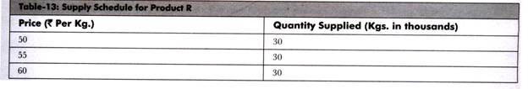
Prepare a supply curve for the supply schedule of product R and determine the type of elasticity of supply demonstrated by the supply curve.
Solution:
The supply curve for product R is shown in Figure-19:
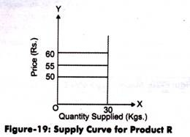
Figure-19 shows that the supply of product R remains constant at 30,000 Kgs. However, the price changes from Rs. 50 to Rs. 60 at the same supply rate. Therefore, the supply of product X is perfectly inelastic (e = 0).

