MICRO ECONOMICS
B.A PART 1
EXCEPTION OF LAW OF SUPPLY
Top of Form
Bottom of Form

Exceptions of Law of supply
The law of supply states that the sellers are willing to sell more goods at a higher market price of a commodity and vice-versa. In other words, when the price of a commodity increases its supply increases and when the price of a commodity decreases its supply decreases, other things being constant. Thus, there is a direct relationship between the price of a commodity and its supply. However, there are some exceptions of law of supply.

Exceptions of Law of supply
There are certain circumstances under which the law of supply may not hold true. It means that the price of the commodity and its supply may not move in the same direction. Thus, the exceptions to the law of supply are as follows
- Closure of business
- Agricultural products
- Monopoly
- Competition
- Perishable Goods
- Rare goods
- Out of fashion goods
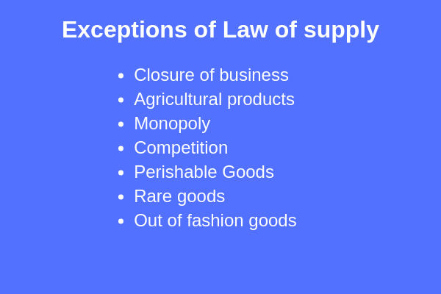
1. Closure of business
When a business is on the verge of closure, the seller may sell the goods even at low prices in order to clear the stock. Thus, in this case, the law of supply shall not hold true.

Browse more Topics under Supply
- Law of supply
- Supply Function
- Movement and Shift of Supply Curve
- Elasticity of Supply

2. Agricultural products
We know that land is a limited resource and thus the agricultural produce can also not be increased beyond a certain level. Hence, even if the prices increase the supply cannot be increased.

3. Monopoly
Monopoly is a situation where there is only a single seller of a commodity. Thus, he is the price maker and has control over the prices.
In such a case, the law of supply may not apply as he may not be willing to increase the supply even if the prices are high.

4. Competition
When there is a cut-throat competition in the market, the sellers may sell more quantity of goods even at low prices. This is a situation where the law of supply will not apply.
5. Perishable Goods
A seller is willing to sell more goods that are perishable in nature even at low prices because if they remain unsold they will yield only loss.
6. Rare goods
The goods that are rare such as artistic or precious goods have a limited supply. The supply of these goods cannot be increased according to their demand or rising prices.

Thus, even if their price increases their supply cannot be increased. In this case, also the law of supply shall not apply.

7. Out of fashion goods
The latest goods that are in fashion have high prices. But, the out of fashion goods have low prices.
The sellers may sell them out of fashion goods even at low prices. As these will become dead inventory and also in order to realize the amount invested in the inventory.

